**Shubhan Singh**

**2022300118**

**SE-Comps B/Batch C**

**18th January 2024**

**Scilab no.1: Introduction to Scilab and its basic commands**

**Program No.1** :- Write a program to input two matrices, calculate their sum and product

where:

A= $\left[\begin{matrix}12 & 22 & 32 & 68 \\ 42 & 52 & 62 & 77 \\ 11 & 21 & 31 & 84 \\ 24 & 55 & 66 & 10\end{matrix}\right]$

B= $\left[\begin{matrix}14 & 25 & 36 & 15 \\ 28 & 38 & 19 & 59 \\ 16 & 35 & 44 & 87 \\ 17 & 65 & 43 & 24\end{matrix}\right]$

**Code :-**

clc;

A=[12 22 32 68;42 52 62 77;11 21 31 84;24 55 66 10];

B=[14 25 36 15;28 38 19 59;16 35 44 87;17 65 43 24];

disp(A);

disp(B);

C=A+B;

D=A*B;

printf("The sum is:")

disp(C);

printf("The product is:");

disp(D);

**Output :-**

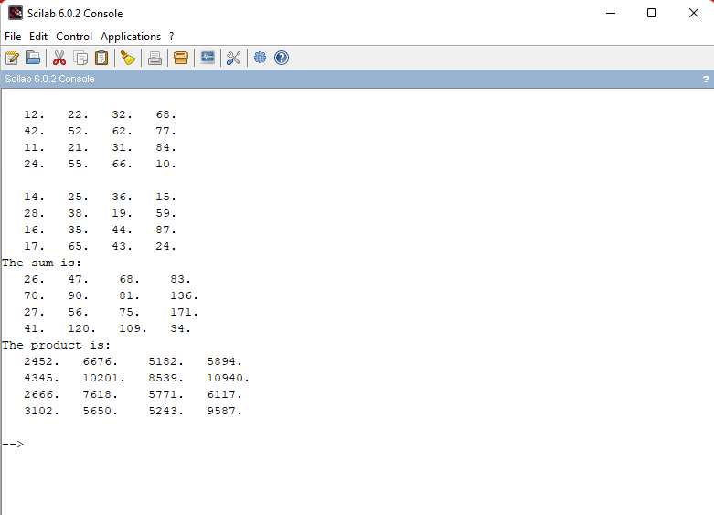

**Program No. 2:-** Write a program to input a matrix, find its determinant, trace and transpose where:

A= $\left[\begin{aligned}1 3 5 \\ 2 4 1 \\ 1 2 3\end{aligned}\right]$

**Code**:-

clc;

A=[1 3 5;2 4 1;1 2 3];

printf("Matrix A is:");

disp(A);

printf("Determinant of matrix A is: ");

disp(det(A));

printf("Transpose of matrix A is:");

disp(A');

printf("Trace of matrix A is: ");

disp(trace(A));

**Output** :-

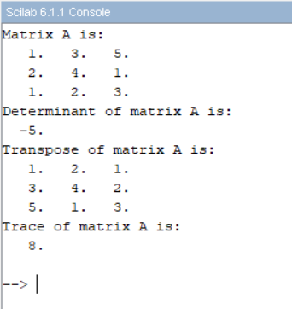

**Program No. 3 :-** Write a program to extract lower and upper triangular matrix where:

A= $\left[\begin{aligned}1 3 5 \\ 2 4 1 \\ 1 2 3\end{aligned}\right]$

**Code** :-

clc

A=[1 3 5;2 4 1;1 2 3];

printf("The matrix A is: \n");

disp(A);

printf("The upper triangular matrix of A is : \n");

disp(triu(A));

printf("The lower triangular matrix of A is : \n");

disp(tril(A));

**Output** :-

**Program no. 4** :- Generate 2 random matrices and print their sum and product. Also print their upper triangular as well as lower triangular matrices.

**Code** :-

clc

A=rand(4,4);

printf("The random matrix A is : \n");

disp(A);

B=rand(4,4);

printf("The random matrix B is : \n");

disp(B);

C=A+B;

D=A*B;

printf("Sum of two random matrices : \n ")

disp(C);

printf("Product of two random matrices : \n")

disp(D);

printf("The upper triangular matrix of A is : \n");

disp(triu(A));

printf("The lower triangular matrix of A is : \n");

disp(tril(A));

printf("The upper triangular matrix of A is : \n");

disp(triu(B));

printf("The lower triangular matrix of A is : \n");

disp(tril(B));

**Output** :-

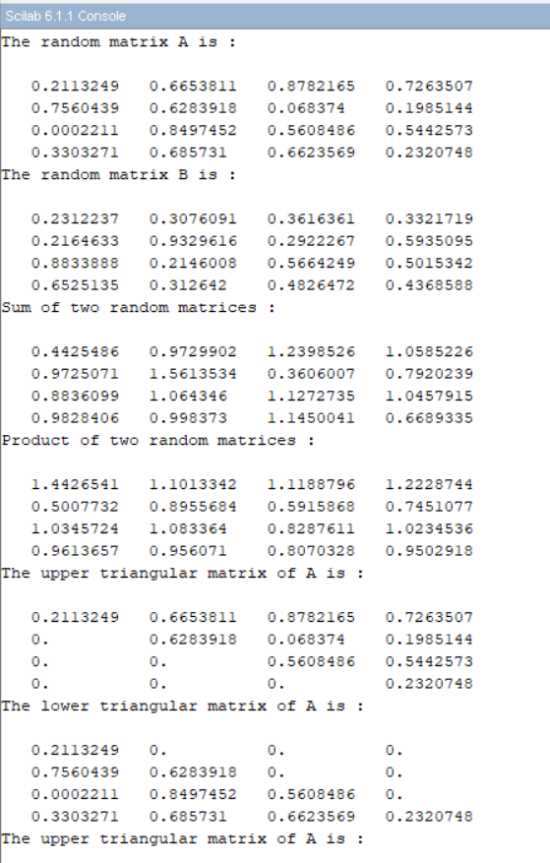

**Program No. 5** :- Write a program to input a matrix, find the product and sum of all the elements of A. also print row wise and column wise sum and product of the matrix where:

A= $\left[\begin{aligned}1 3 5 \\ 2 4 1 \\ 1 2 3\end{aligned}\right]$

**Code** :-

clc;

A=[1 3 5;2 4 1;1 2 3];

printf("the matrix A is: \n");

disp(A);

S=sum(A);

printf("The sum of all entries of A is: ");

disp(S);

P=prod(A);

printf("The product of all entries of A is:");

disp(P);

B=sum(A,'r');

printf("The rowwise sum of A is: ");

disp(B);

C=sum(A,'c');

printf("The columwise sum of A is: ");

disp(C);

D=prod(A,'c');

printf("The columwise product of A is: ");

disp(D);

E=prod(A,'r');

printf("The rowwise product of A is: ");

disp(E);

**Output** :-

